Flagging instructions:

There are 3 types of files for each cruise:

**\*.png** – plots of flagged profiles

**Flag_report**… contains data values of each flagged profile and the explanation why is the point flagged

**HUD99054_change_flag_log.xlsx** is used to log changes of flags byentering desired flag value in thelast column (QC_changed). Once the flages have been changed save the file using the same file name.

All 3 files can be open in separate windows. The windows could be arranged on the screen for easier flagging.

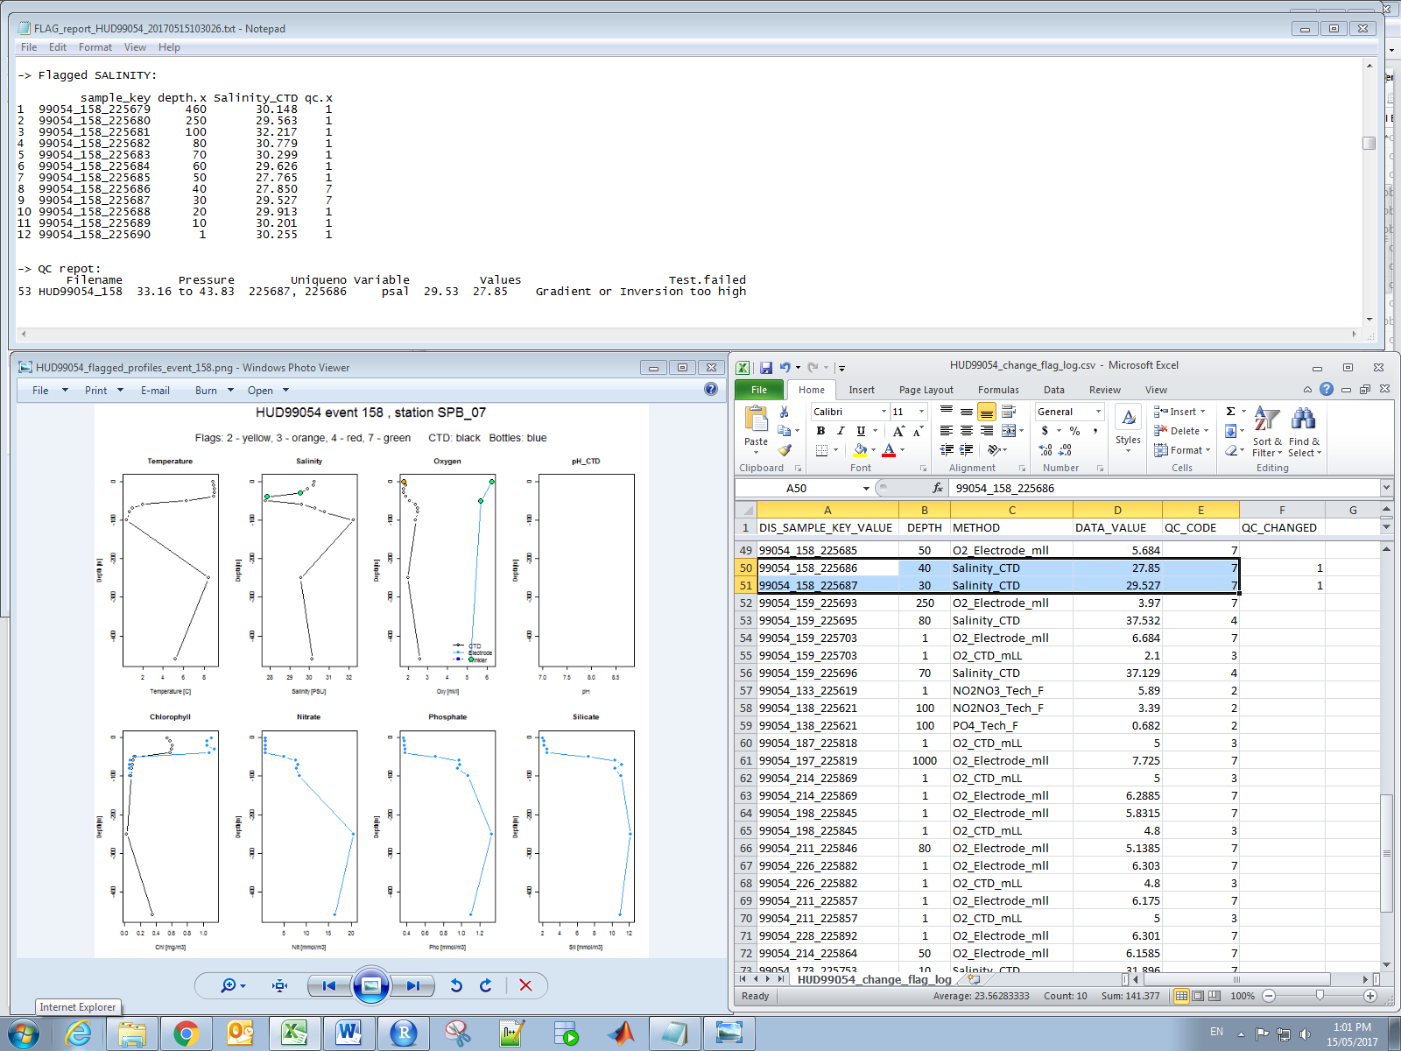

Flags:

0 – Not flagged; 1 – Correct; 2 – Inconsistent; 3 – Doubtful; 7 – Investigate

4 – Erroneous (currently all negative values are flagged 4)